Q-ONE LAPTOP BIOS update process

Firstly use formatted SSD (means the SSD storage space can be see in computer) to install into Q-ONE laptop. Let’s leave the SSD formatting process latter.

PART 1 Formatting the U drive Process

1)Decompression the file 
2)Formatting the U disk and select FAT32
3)Rename the U disk name to “WINPE “
4)Press “Start “ to formatting the U disk
5)After formatting completed then copy the BIOS files into the U disk

(Please note copy the file directly to U disk, do not create a new folder)

BIOS file like follow
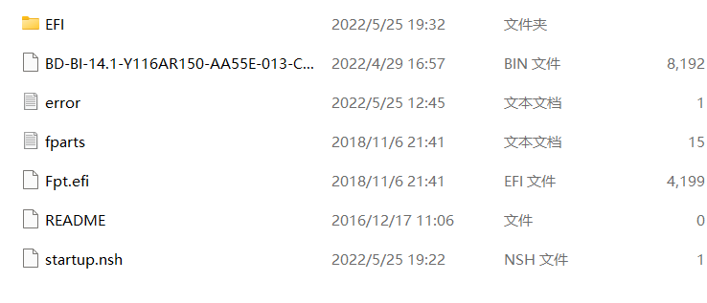
PART 2 The process of loading BIOS
- Keep laptop turn off
- Plug the U disk
- Press “Power on “
- Keep press F7
- Select the U disk file, when you see “Do you want to continue?
Please enter “ y ” to continue
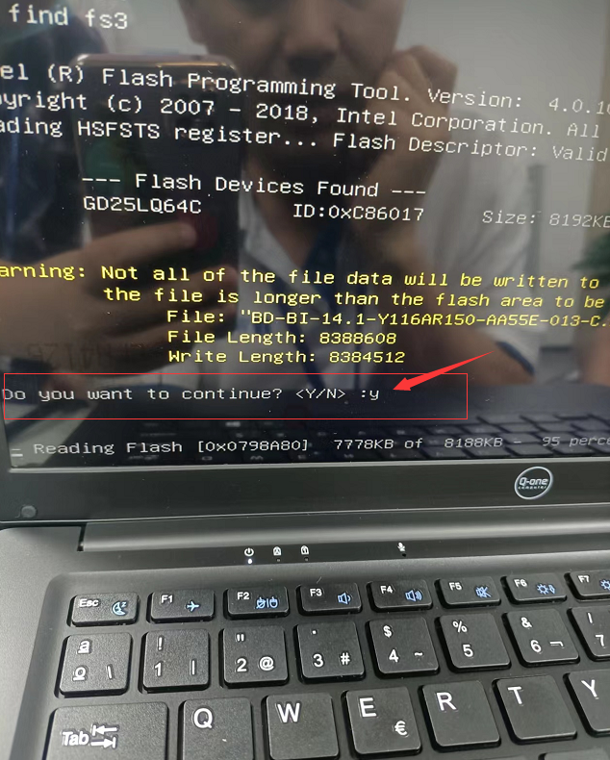
- Wait the uploading process until 100%
- Remove the U disk

PART 3 Check the BISO updated or not
- Keep laptop turn off
- Turn on power
- Keep press ESC when power on light turn on

This is new BIOS version.
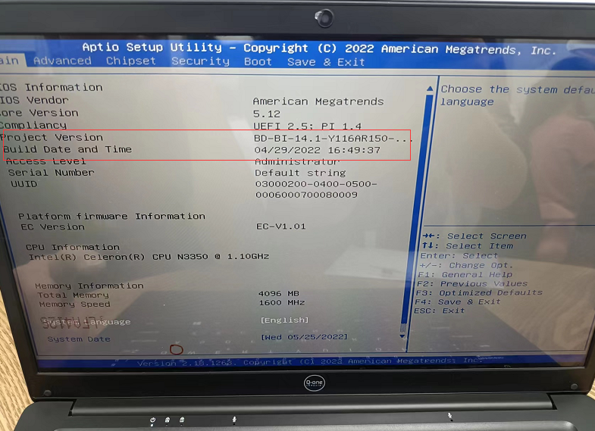

Keep press turn off button to go back, then turn on the laptop .

PART 4 Check the windows ID active or not
- Open this icon
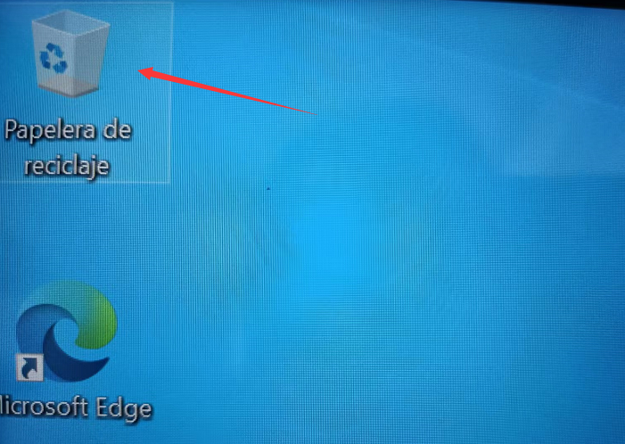
- Open this icon
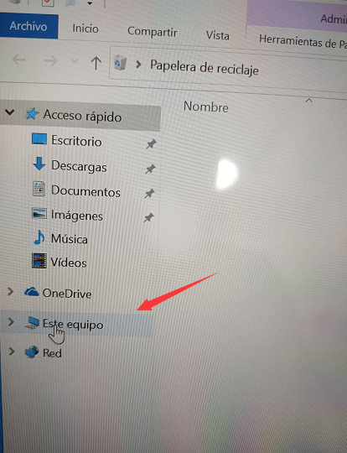
- Then press mouse right button in “empty space “
- Select 
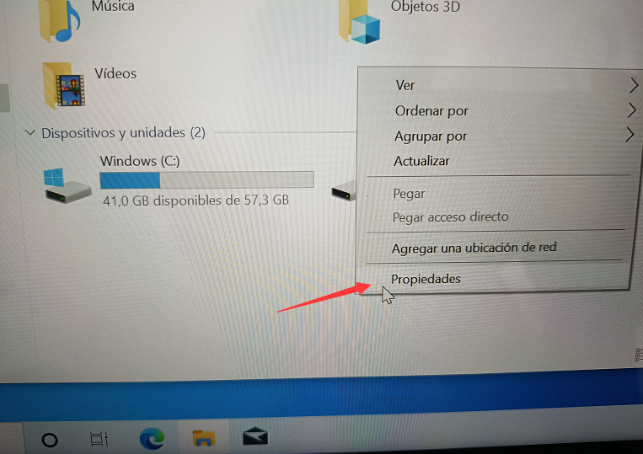

- Windows ID show like this
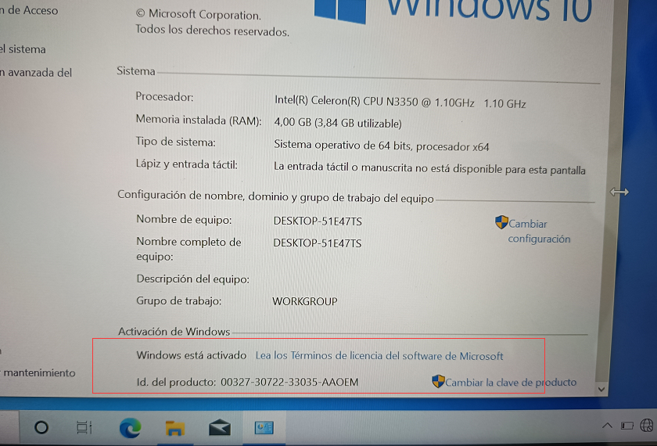

After above steps finished, going to testing WIFI connection .

